

**Welcome to**

**YOUR LOGO HERE**

Information Technology Solutions

Open the app and watch as many videos as you’d like. With hundreds of videos in the **Quillo Pro** library and more added weekly, you can explore new and inspirational topics in three categories: **Learn Together,** **Share Experiences**, and **Take a Moment.** It’s amazing how just a few minutes a day can provide the boost or support you just might need!

***We appreciate you!***

We are investing in **Quillo Pro**, an app that shares short videos with stories and messages to:

* Make you smile or laugh
* Give you a new idea to consider
* Share key news from <Organization Name>
* Emphasize why your work is important

Each day, you will get a choice of new, positive videos (60 seconds or less), delivered to your smartphone. Video messages are from people across the country, as well as right here at <Organization Name> – celebrating success, sharing information, and helping build the relationships that make life so important to each of us. They will emphasize why coming to work makes a difference – and how ***you*** make a difference.

**TAKE A MINUTE…**

**JUST FOR YOU.**

Whether it’s getting ready to start a shift or winding down after a long day, **Quillo Pro** has something for you. It’s a busy world, but take some time for yourself. **Quillo** **Pro** knows you are worth it – and we agree!

**TWO WAYS TO QUILLO, SAME GREAT EXPERIENCE!**

• Download the **Quillo** app to your smartphone/tablet

• Access it on a desktop at [**www.myQuillo.com**](https://d.docs.live.net/916877a7eb892d7a/Documents/Publicity%20Docs%20(OneDrive)/Quillo%20Nation/www.myQuillo.com) (click Desktop Login).

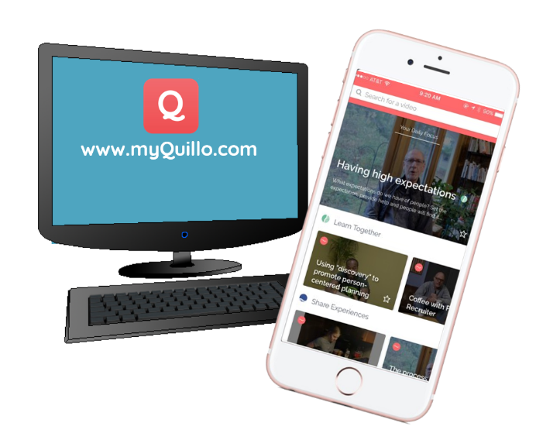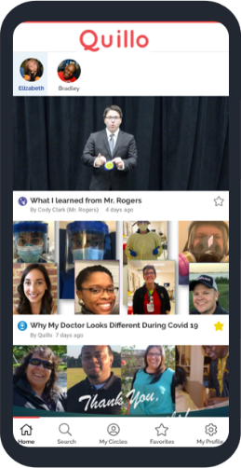

A communication platform designed to **engage**, **inspire**, and **educate** YOU. Experience **Quillo** **Pro** on a smartphone OR desktop!

Watch daily **60-second videos**, sent from our organization as well as voices across the country.

Reconnect with the **“WHY”** of what you do with support from your peers.

**To learn more or sign up, contact:**

**<Contact Name (Email Address/Phone)>**

***Better Relationships. Better Lives.***

[**www.myQuillo.com**](http://www.myQuillo.com)

**@myQuillo**

**You are so important to us and the people supported by <Organization Name>.**