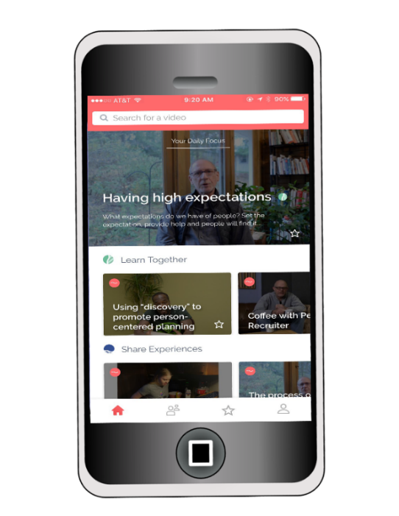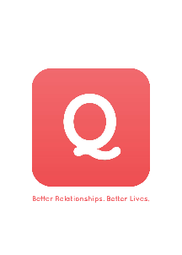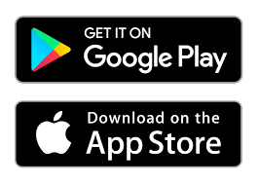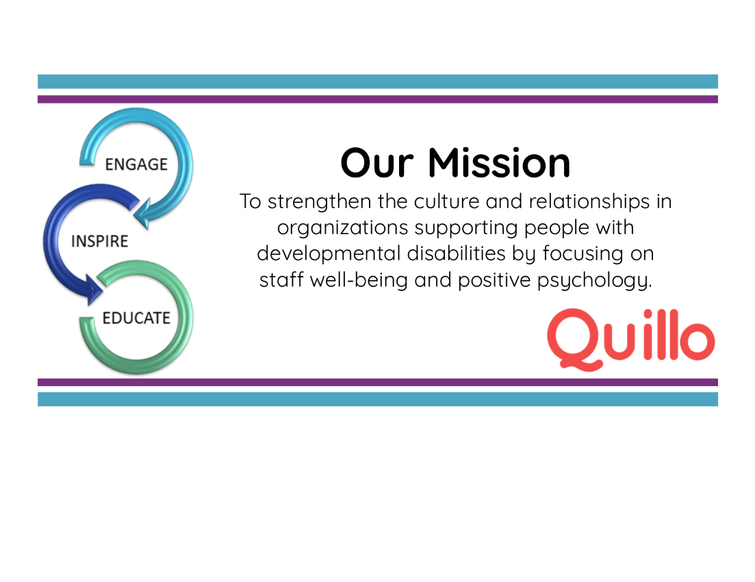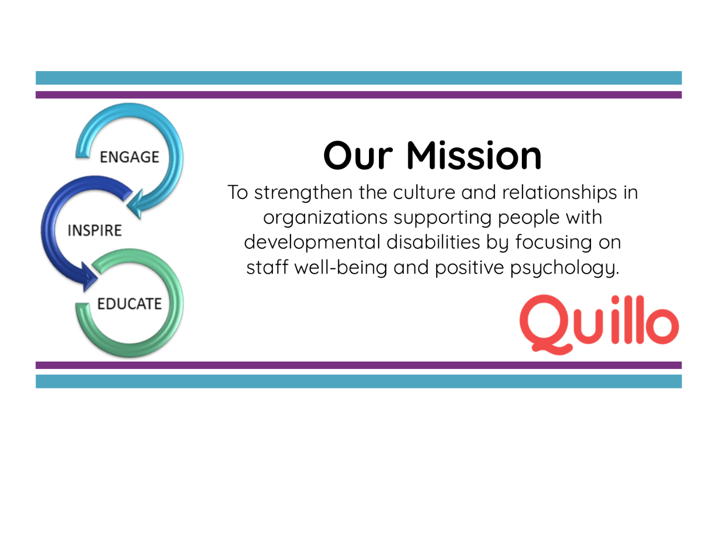

A communication platform designed to **engage**, **inspire**, and **educate** YOU. Experience **Quillo** on your smart phone OR a desktop!

Watch daily **60-second videos**, sent from our organization as well as voices across the country.

Reconnect with the **“WHY”** of what you do with support from your peers.

**What is Quillo?**

At <Your Org Here>, we believe a positive work environment starts with a strong workplace culture, starting right here with orientation. We want to continue to connect with you, from Day 1.

**Quillo** is a way for us to do that, ensuring that you feel supported, connected, and confident in your job. Access **Quillo** from your smart phone OR desktop. If you’d like to sign up for **Quillo**, fill out this form and drop it off with ____________________.   
Welcome to the team!

**- CEO’s name**

**YOUR LOGO HERE**

Introducing **Quillo**

*Better Relationships. Better Lives.*

[**www.myQuillo.com**](http://www.myquillo.com/)



**Two ways to Quillo, same great experience!**

(a)Download the Quillo app to your smartphone OR (b) Access it on a desktop at [www.myQuillo.com](https://d.docs.live.net/916877a7eb892d7a/Documents/Publicity%20Docs%20(OneDrive)/Quillo%20Nation/www.myQuillo.com).

**Yes! I would like to sign up for the Quillo app!**   
(Cut form here and drop it with the name listed above)

Name: _________________________________________________________

Phone: ____________________ Email: ______________________________

*Questions or comments? Make a note below!*