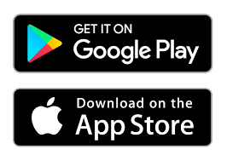

Introducing **Quillo**

*Better Relationships. Better Lives.*

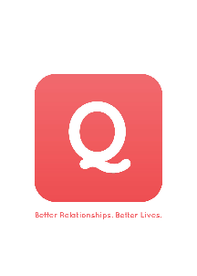

**YOUR LOGO HERE**

**Two ways to Quillo, same great experience!**

(a)Download the **Quillo** app to your smartphone OR (b) Access it on a desktop at <www.myQuillo.com>.

A communication platform designed to **engage**, **inspire**, and **educate** YOU. Experience **Quillo** on your smart phone OR a desktop!

Watch daily **60-second videos**, sent from our organization as well as voices across the country.

Reconnect with the **“WHY”** of what you do with support from your peers.

[**www.myQuillo.com**](http://www.myquillo.com/)

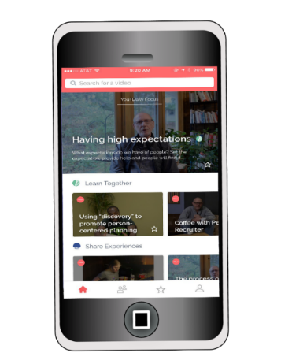

**What is Quillo?**

Introducing **Quillo**

*Better Relationships. Better Lives.*



**YOUR LOGO HERE**

**Two ways to Quillo, same great experience!**

(a)Download the **Quillo** app to your smartphone OR (b) Access it on a desktop at <www.myQuillo.com>.

A communication platform designed to **engage**, **inspire**, and **educate** YOU. Experience **Quillo** on your smart phone OR a desktop!

Watch daily **60-second videos**, sent from our organization as well as voices across the country.

Reconnect with the **“WHY”** of what you do with support from your peers.

[**www.myQuillo.com**](http://www.myquillo.com/)



**What is Quillo?**

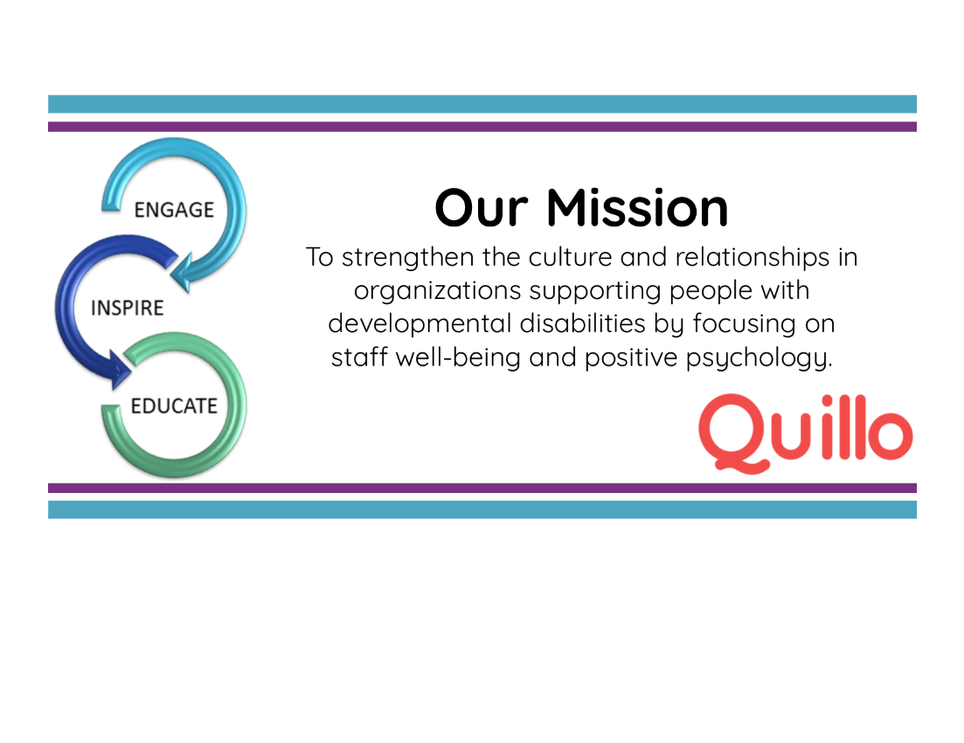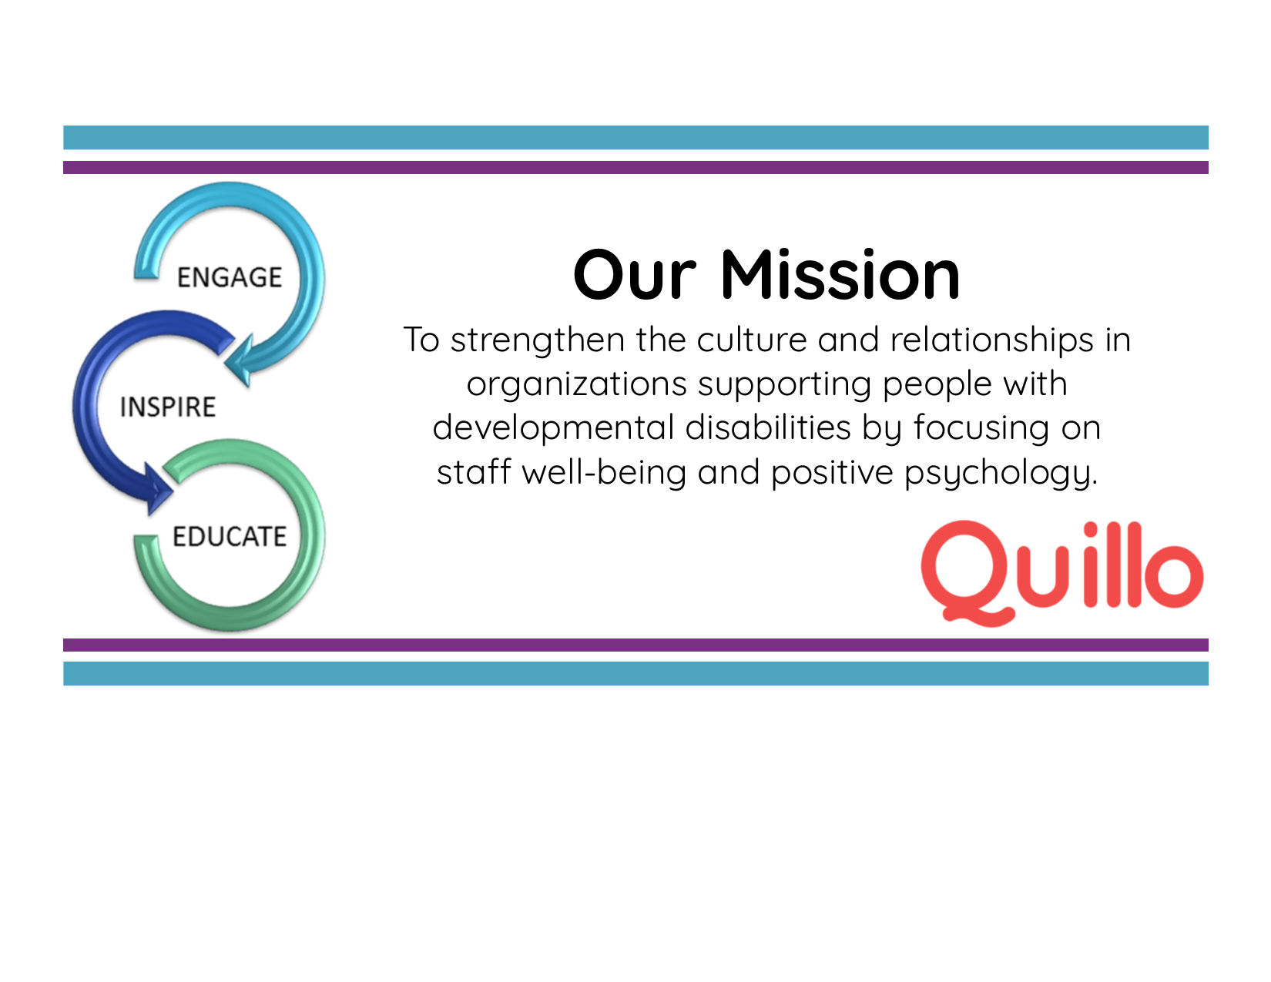

At <Your Org Here>, we believe a positive work environment starts with a strong workplace culture, starting right here with orientation. We want to continue to connect with you, from Day 1.

**Quillo** is a way for us to do that, ensuring that you feel supported, connected, and confident in your job. Access **Quillo** from your smart phone OR desktop. If you’d like to sign up for **Quillo**, fill out this form and drop it off with ____________________.   
Welcome to the team!

**- CEO’s name**

**YOUR LOGO HERE**

Yes, I would like to sign up for the **Quillo** app! (Tear form here)

Name____________________________________

Phone: ________________________________

Email: _________________________________

Any questions or comments?

***Better Relationships. Better Lives.***

At <Your Org Here>, we believe a positive work environment starts with a strong workplace culture, starting right here with orientation. We want to continue to connect with you, from Day 1.

**Quillo** is a way for us to do that, ensuring that you feel supported, connected, and confident in your job. Access **Quillo** from your smart phone OR desktop. If you’d like to sign up for **Quillo**, fill out this form and drop it off with ____________________.   
Welcome to the team!

**- CEO’s name**

**YOUR LOGO HERE**

***Better Relationships. Better Lives.***

Yes, I would like to sign up for the **Quillo** app! (Tear form here)

Name____________________________________

Phone: ________________________________

Email: _________________________________

Any questions or comments?

**YOUR LOGO HERE**