DSP Appreciation Week is
September 13-19, 2020!

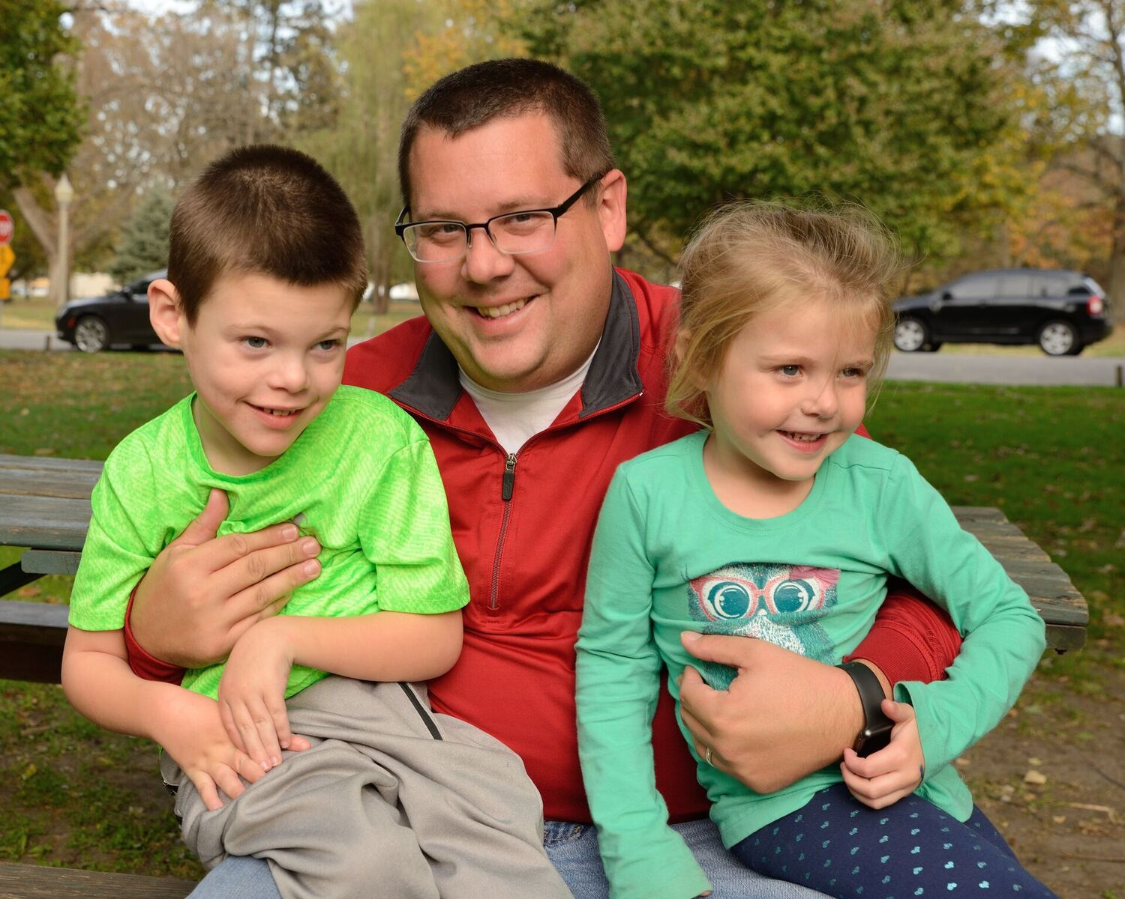
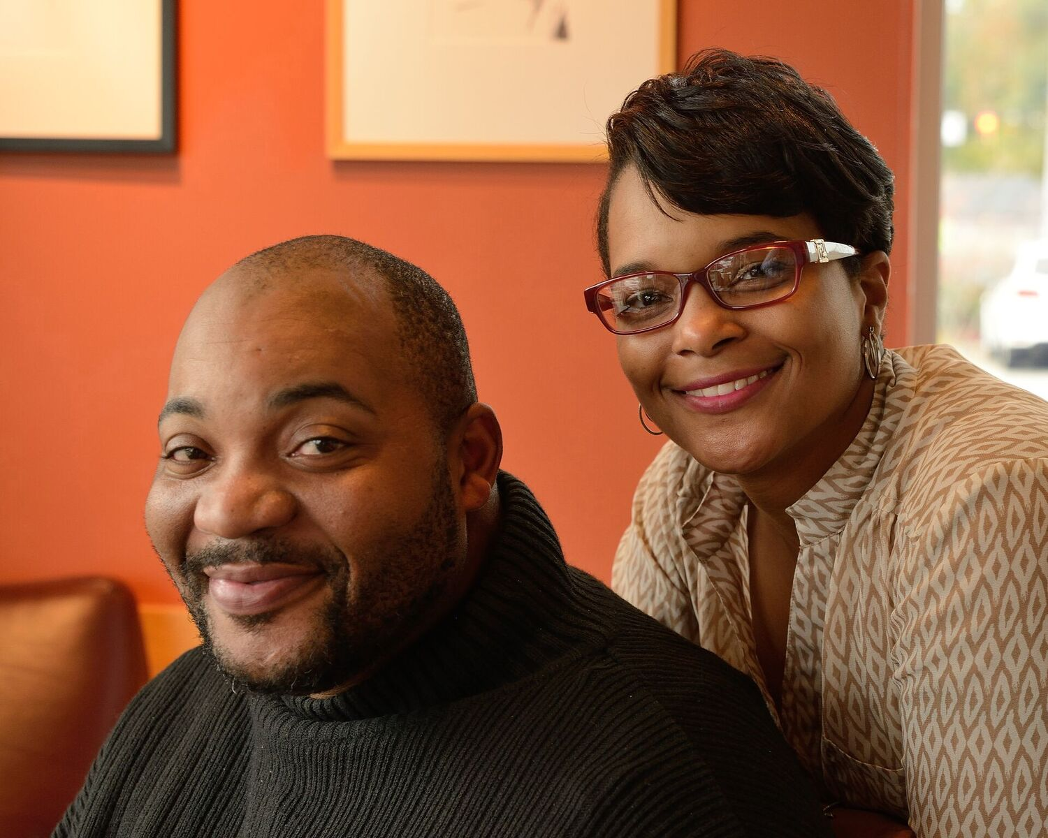
We are thrilled that you and your family are part of the ORGANIZATION community, where we see so much growth in people every day. So much of this work is done by those who work with your family member, our Direct Support Professionals. We wanted you to know that DSP Appreciation Week is coming up! Everyone appreciates hearing “thank you” for a job well done.

We’ll be showing them our thanks in various ways during that week. We encourage you to say an extra special “Thank You!” the week of September 13-19. Whether a kind word, a handwritten note, or a “thank you,” it will mean a lot!
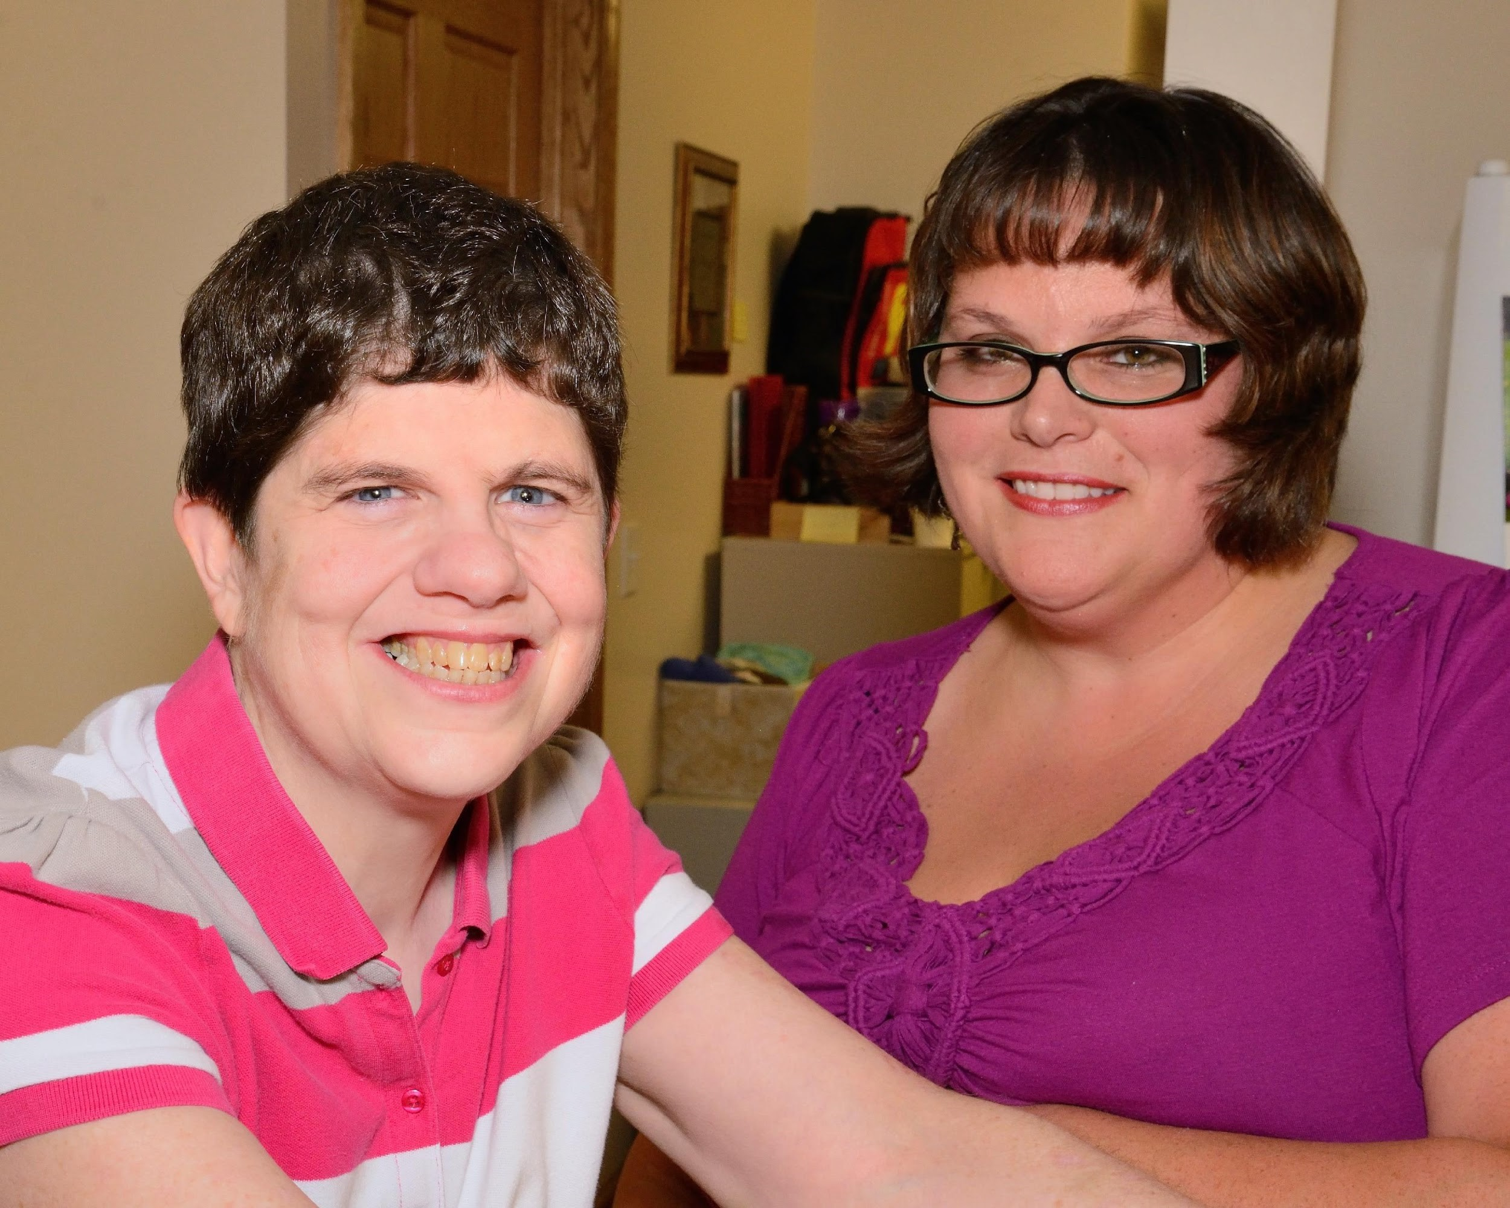
Thank you for being part of the ORGANIZATION community!
Organization Logo Here

